### **Reflective Report on Recognizing British Sign Language Using AI**

#### Introduction

#### The purpose of this project was to propose a trained AI model by utilizing Artificial Neural Networks (ANN) to identify British Sign Language (BSL) fingerspelling. Thus, the main goal of the work done in this project was to create an algorithm that gives means to recognize BSL alphabet fingerspelling through a webcam-based GUI interface. This initiative directly relates to a problem of language deprivation in children with hearing impairment as it seeks to enable sign language recognition with a view of helping children make basic communication.

#### Data Collection Approach

#### This dataset is considered to be very essential when it comes to training of any machine learning model. The method used for data collection included photographing the fingerspelling of the BSL alphabet by utilizing OpenCV using a webcam. The key steps in the data collection process were;

#### 1. Capturing Data: The script used to open the webcam and make 40-50 successive snapshots of each letter with the webcam on for 6 seconds before it moved to the next letter after which there was 10-second break. This approach helped in making sure that data was collected methodologically and exhaustively for each of the letters.

#### 2. Variety in Data: To increase the model’s reliability, angles and scales were diversified. This diversity allowed the learning of the model to better generalize to other real-life situations. Additional data was added and captured and modified to ensure it has diversity and matches what was needed for the project.

#### 3. Processing Images: By applying the MediaPipe library, the identification of the landmarks of the hands was performed for each of the images. The process followed was the conversion of the image into the RGB model as well as detecting the coordinates of each landmark and obtaining their x, y, z values. These were the landmarks that were used in training of the model.

#### Core Model Design

#### The focus of the work was to train an ANN to recognize the fingerspelling of the BSL alphabet. This model was formulated on the architecture of a Sequential neural network. The key steps in the model design and training process were:

#### 1. Model Architecture

#### Input Layer: The input layer accepts the flattened landmark coordinates.

#### Hidden Layers: A hidden layer with 256 units and another hidden layer with 128 units both of which are immediately succeeded by a Dropout layer. The activation function that was used is ReLU which is used for non-linear transformations.

#### Output Layer: To classify the groups of BSL letters, a softmax layer was also used. This layer gives a probability distribution of the available classes by which the most probable letter can be identified.

#### 2. Compilation and Training

#### Optimizer: This was achieved with the help of Adam optimizer that is efficient and which incorporates the learning rate itself. It integrates the stochastic gradient descent extension features of other two options, namely AdaGrad and RMSProp.

#### Loss Function: Besides, categorical cross-entropy was selected as this is a multi-class classification task. The loss function at the disposal here is suitable for models for training, where each training example will be of one of several classes.

#### Metrics: Previously, accuracy was applied in model assessment as it directly indicated the proportion of correct predictions by the model.

#### 3. Training Process

#### The training data set was used with an 80/20 ratio of the total data set where the 80% was used for training and 20% for the validation data set. This division made sure that the model was trained with a significant part of the data but at the same time checked for overfitting on the validation set.

#### Model Evaluation and Results

In the final testing, the model successfully reached the desired performance measures and proved its capacity of predicting unseen data on the letters trained and tested. The performance quality of the model reported by ASPP was measured by the validation accuracy. To make further analysis about the learning behavior of the training process, matplotlib was used. That plot of training and validation accuracy as well as the training and validation loss proved that the model performed quite well on both training and validation.

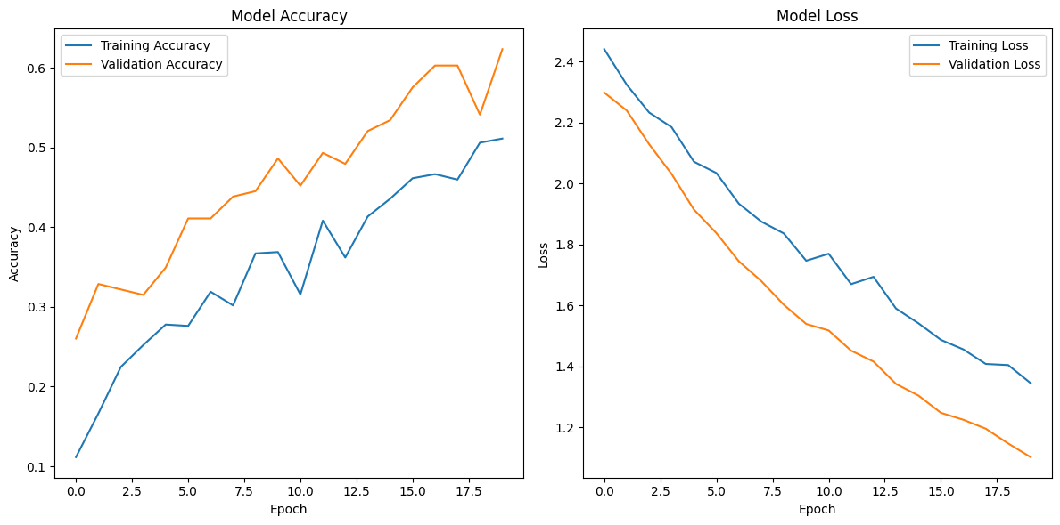

**Real-time Predictions**

To test the model for real-time prediction a video from the webcam was fed to the model in real-time after training the model. It then predicts the letter by drawing this from the detected hand landmarks. This real-time application clearly proved the usefulness of this model in handling the general communication through sign language recognition. Although there is still some improvement needed, majority of the letters were able to be recognized and predicted well. Some letters with similarity proved more difficult to predict accurately.

**Conclusion**

This project was able to show how ANN can be used in recognizing BSL fingerspelling based on the results obtained. Therefore, having carried out data collection, proper model development and a proper model evaluation, the solution produced was a quite good model capable of predicting most BSL alphabetical letters. This solution, with improvement can play a major role in ensuring that communication barriers are eased for children with hearing impairments, and thus their cognitive as well as social emotional development enhanced. The project was, thus, focused on the ability of AI in increasing both accessibility and inclusiveness of the services related to communication especially in people with disabilities.